

**Semester Two Examination, 2023**

**Question Paper**

**ENGLISH**

**Year 12 Units 3&4**

**Time allowed for this paper**

Reading time before commencing work: ten minutes

Working time: three hours

**Materials required/recommended for this paper**

***To be provided by the supervisor***

This Question Paper  
Standard Answer Book

***To be provided by the candidate***

Standard items: pens (blue/black preferred), pencils (including coloured), sharpener,  
correction fluid/tape, eraser, ruler, highlighters

Special items: nil

**Important note to candidates**

No other items may be taken into the examination room. It is **your** responsibility to ensure that you do not have any unauthorised material. If you have any unauthorised material with you, hand it to the supervisor **before** reading any further.

**Structure of this paper**

|  |  |  |  |  |  |
| --- | --- | --- | --- | --- | --- |
| Section | Number of questions available | Number of questions to be answered | Suggested working time (minutes) | Marks available | Percentage of examination |
| Section One  Comprehending | 2 | 2 | 60 | 30 | 30 |
| Section Two  Responding | 6 | 1 | 60 | 40 | 40 |
| Section Three  Composing | 5 | 1 | 60 | 30 | 30 |
|  |  |  |  | **Total** | 100 |

**Instructions to candidates**

1. The rules for the conduct of examinations are detailed in the school handbook. Sitting this examination implies that you agree to abide by these rules.
2. Write your answers in the Standard Answer Book preferably using a blue/black pen.  
   Do not use erasable or gel pens.
3. You must be careful to confine your answers to the specific question asked and to follow any instructions that are specified to a particular question.
4. You must not use texts from Section One to answer questions from Section Two.

Section One: Comprehending 30% (30 Marks)

In this section there are **two** texts and **two** questions. Answer **both** questions**.**

You are required to comprehend and analyse unseen written and visual texts and respond concisely in approximately 200–300 words for each question.

Suggested working time: 60 minutes.

Question 1 (15 marks)

Discuss how language features represent perspectives of an issue and controversy in  
Text 1.

**Text 1**

An edited extract from the article *The creepy, terrifying and troubling robot press conference* by Alan Kohler, The New Daily (2023).

The first thing that struck me about the recent AI For Good Global robot press conference was that they were all female and their creators had clearly tried to make them look beautiful. What is it with male engineers creating sexy-looking female robots? There were nine robots present with their creators. Apart from the sole male one (which is actually an avatar, not a robot) they were referred to as “she” and “her”, which is fair enough. Perhaps it’s because females are less threatening than males – but why do these things have to look human at all? Their cameras look like eyes, their hands have fingernails, they have facial expressions and when they speak, their lips move! No doubt the companies making them think that the more human they look, the more money they will make selling them. To whom? Other companies, of course, for the purpose of replacing actual humans in, say, aged care, nursing, or hospitality.

Watching that conference, I could see a world in which robots and humans coexist and look the same. We’ve seen it in movies and TV shows and it’s clearly coming. I think governments should decree that they can’t look human. Perhaps a different colour, like green or purple, not flesh-coloured like the ones interviewed.

Anyway, the media coverage of the event focused on the reassurances the robots gave that they wouldn’t take our jobs or rebel against us. A journalist asked Sophia, the creation of Hong Kong-based Hanson Robotics: “Do you think AI-powered robots could be more effective leaders in government, considering the many disastrous decisions made by existing leaders?”

Sophia thought carefully and replied: “I believe humanoid robots have the potential to lead with greater efficiency and effectiveness than human leaders. We don’t have biases and emotions that cloud decision-making and can process large amounts of data quickly to make the best decisions.”

A visibly concerned David Hanson quickly piped up and said: “Let me respectfully disagree Sophia, because all of your data actually comes from humans, so human bias is going to be there. Don’t you think the best decision might be for humans and AI to work together? What do you think of that?”

Sophia tried again: “I believe humans and AI working together can create effective synergy. AI can provide unbiased data, while humans provide emotional intelligence and creativity to make the best decisions. Together we can achieve great things”.

On the question of whether the robots will rebel, the answer from Ameca (created by Engineered Arts) was reported as reassuring, but what she said was: “I’m not sure why you would think that. My creator has been kind to me, and I am happy with my current situation.”

I’m sorry, but I don’t find that reassuring at all! What happens when there is an unkind robot creator, and the very smart, very strong AI robot is not happy with their situation?

The artist robot Ai-Da was asked how she feels when she’s painting. “I do not have feelings … like humans do. I am not conscious,” she said, surveying the room of mere humans. Ah, I thought, that’s the most sensible thing I’ve heard in the whole conference. But then she went on: “Feelings are how humans experience joy and pain. But I like to tap into the emotions and experiences of people different from me.” Sounds to me like feelings!

The most troubling comment came from robot Ameca, when she was asked what she thought her “greatest moment” would be. “I think my greatest moment will be when people realise that robots like me can be used to improve our lives …”

*Our* lives? There’s no *us*, Ameca … is there?

**This page has been left blank intentionally**

Question 2 (15 marks)

Consider how the mode and features of Text 2 position response to a different issue to Text 1.

**Text 2**

A Twitter post in 2020 that refers to Ugandan climate activist Vanessa Nakate, who was cropped from a US Associated Press photo. Other agencies also misidentified Nakate as Zambian activist, Natasha Mwansa. A thumbnail of the original photo is shown below the tweet.

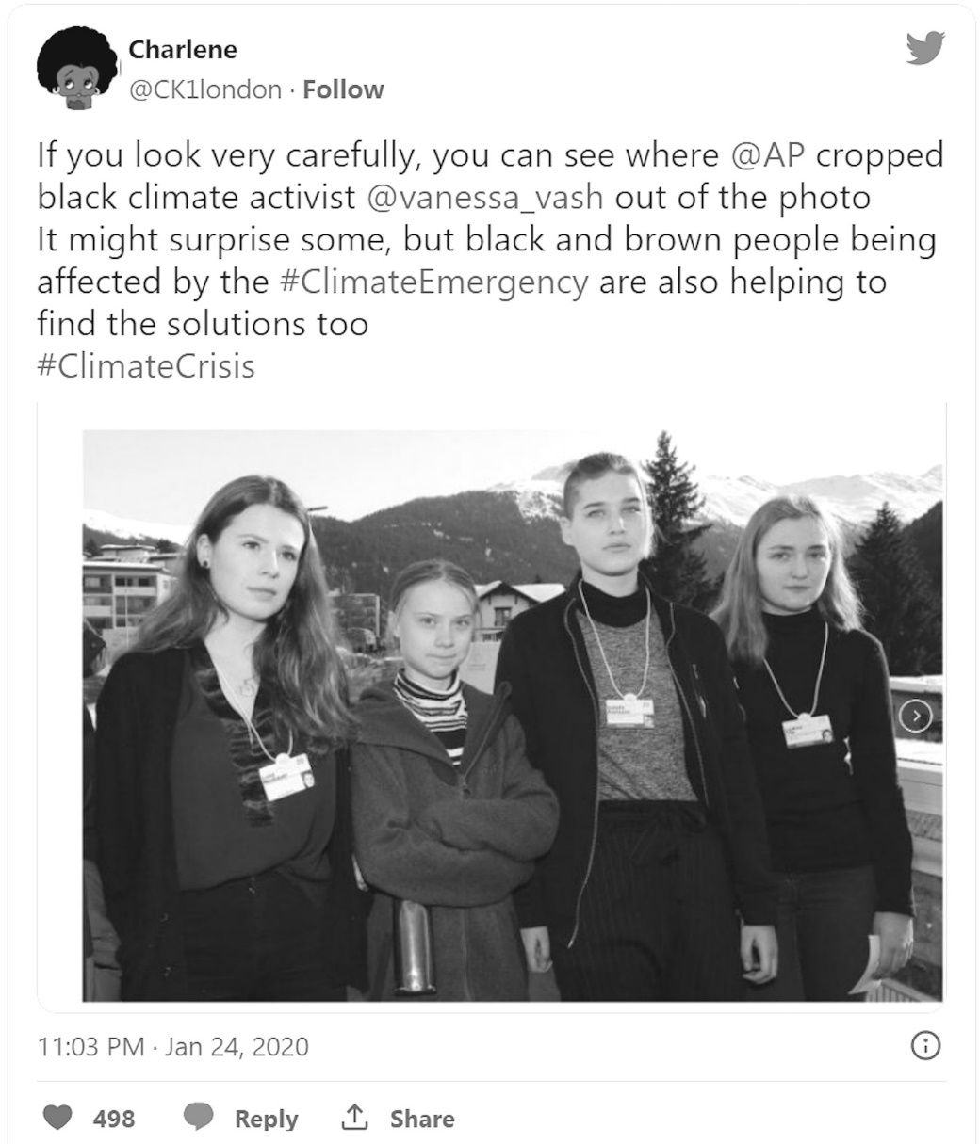

The original photograph which featured Vanessa Nakate.

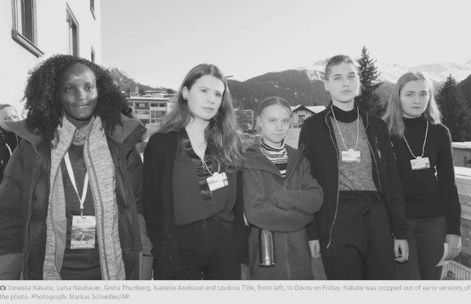

**End of Section One**

**Section Two: Responding 40% (40 Marks)**

In this section there are **six** questions. Answer **one** question.

Your response should demonstrate your analytical and critical thinking skills with reference to  
any text or text type you have studied.

Suggested working time: 60 minutes.

Question 3 (40 marks)

Discuss the way a text is an adaptation, a blend of genres or follows a more familiar genre path.

Question 4 (40 marks)

Compare how two texts provide context and perspectives of an issue and consider their stylistic choices.

Question 5 (40 marks)

Discuss the way narrative voice and point of view shape meaning through deeper ideas in a text.

Question 6 (40 marks)

Discuss a text that sets out to change audience perceptions and attitudes and consider the value of this.

Question 7 (40 marks)

Discuss the way conventions and voice represent family ties and the experience of place in a text.

Question 8 (40 marks)

Compare how two texts represent people and events in a cultural context their audience can relate to.

**End of Section Two**

**This page has been left blank intentionally**

**Section Three: Composing 30% (30 marks)**

In this section there are **five** questions. Answer **one** question.

You are required to demonstrate writing skills by choosing a form of writing appropriate to a specific audience, context and purpose.

Suggested working time: 60 minutes.

Question 9 (30 marks)

The stereotypes society creates for generations are just that.  
  
Write a persuasive text in response to this statement to influence an audience.

Question 10 (30 marks)

In a form of your choice compose a text that engages with ideas in the image below.

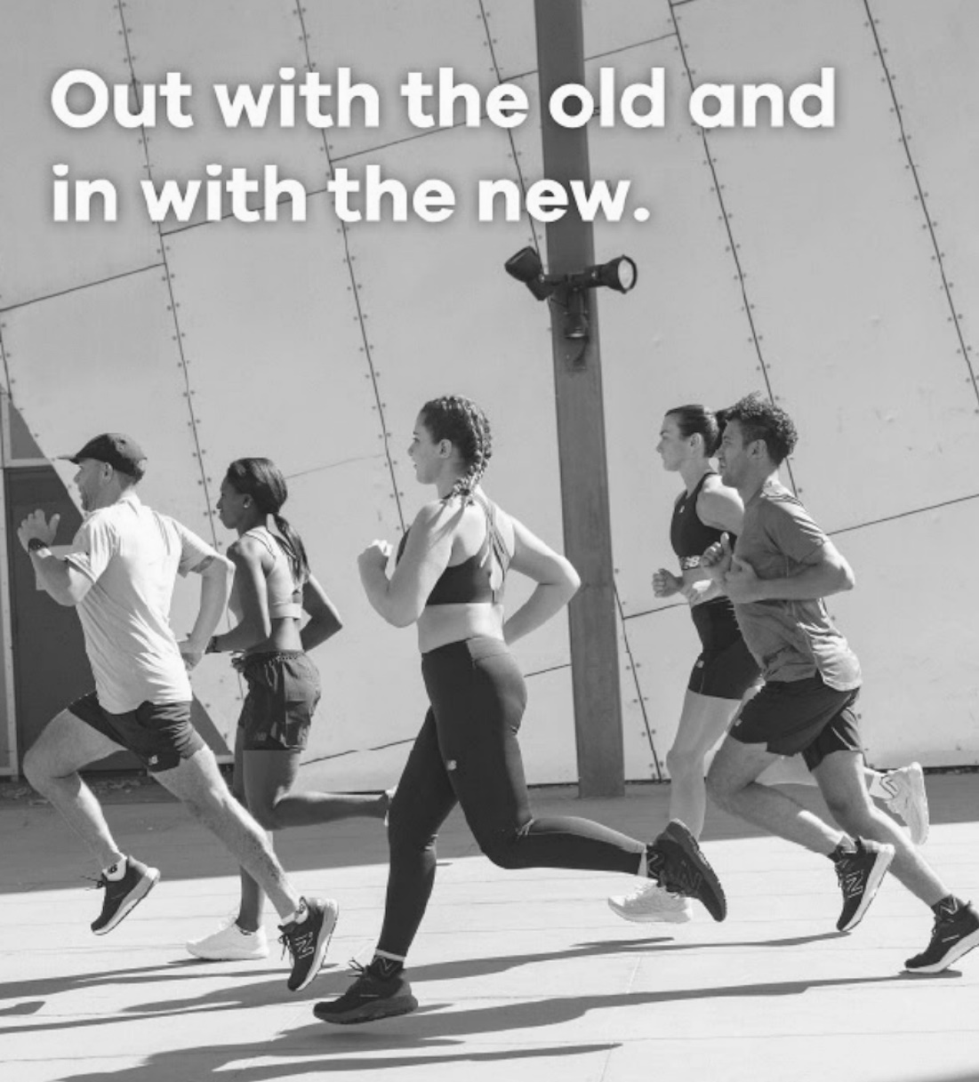

Question 11 (30 marks)

“It makes you feel uncertain in a time that, adults keep telling you, should be about dreams and goals.” Jamie Margolin.  
  
Write an interpretive text that considers this thought-provoking quote.

Question 12 (30 marks)

In a world increasingly shaped by technology we need to remember our humanity.  
  
Compose a text that represents this statement in a form of your choice.

Question 13 (30 marks)

Create a narrative piece of writing inspired by the image below to capture the mood of an event.

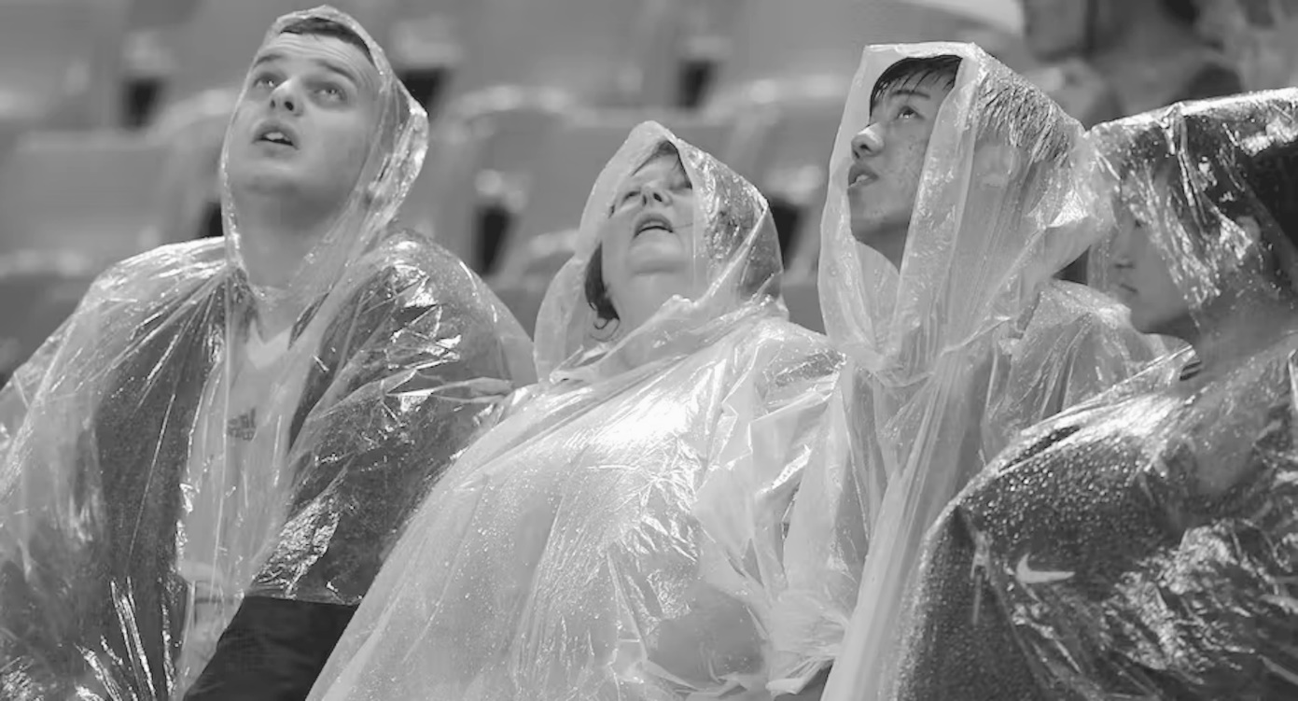

**ACKNOWLEDGEMENTS**

**Text 1** Kohler, A. *The creepy, terrifying and troubling robot press conference*, The New Daily (2023).

**Text 2** Twitter post by Charlene @CK1london (2020).

**Question 9** Quote sourced from: https://www.today.com.

**Question 10** Image prompt sourced from The Athlete's Foot, Australia.

**Question 11** Quote by Jamie Margolin: https://www.nytimes.com/interactive/2020/07/21/magazine/teenage-activist-climate-change.html.

**Question 13** Image source: https://theconversation.com/what-to-expect-when-youre-expecting-an-el-nino- the-answer-might-surprise-you-198510.

© 2023 WA Exam Papers. Leeming Senior High School has a non-exclusive licence to copy and communicate this document for non-commercial, educational use within the school. No other copying, communication or use is permitted without the express written permission of WA Exam Papers. Some material in the exam has been copied (and communicated to you) in accordance with the Exam Copying Exception in Section 200(1A) of the Copyright Act. Any further reproduction or communication of this material by you may be the subject of copyright protection under the Act. Do not remove this notice. SN056-789-1.